Event Fundraising
Information Package

“Good fortune is what happens when opportunity meets with planning.”
- Thomas Edison

Contents:
Introduction …………………………………………………………………… | 3
What Makes a Successful Event....……………………………………… | 4
Getting Started …..………………………………………….……………….. | 5
Additional Information…………………………………………………….. | 6
Basic Guidelines for Tax Receipts………………………………………. | 7
Event Guidelines …………………………………………………………….. | 8
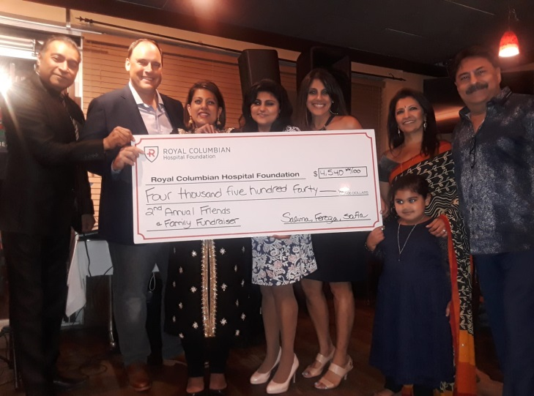  Contact Information…………………………………………………………. | 9

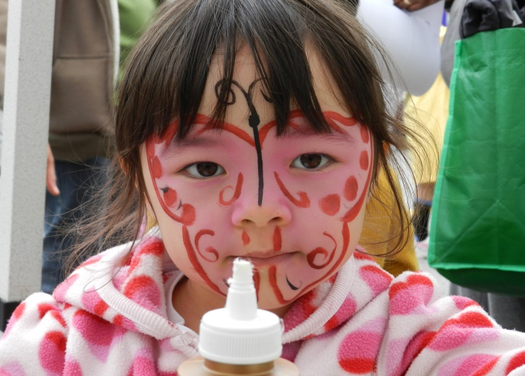
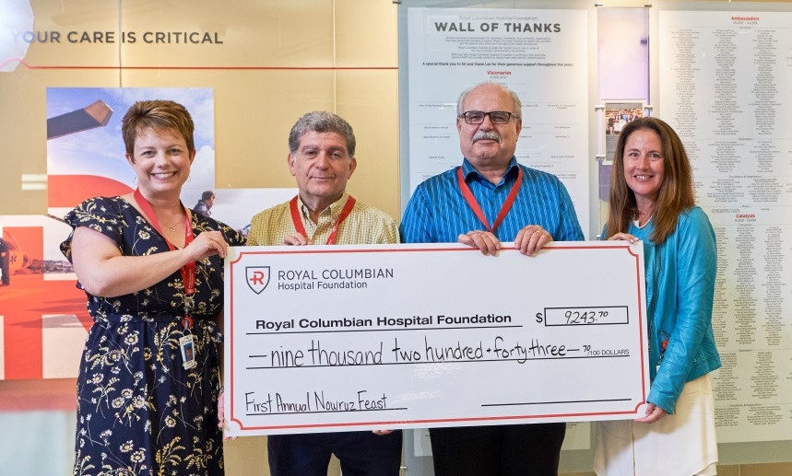

Thank you for your interest in hosting an event to benefit Royal Columbian Hospital Foundation. Hosting or attending a fundraising event or activity is a great way to have fun while also raising funds for Royal Columbian Hospital.
We are grateful for your support. Because of events such as yours, the Foundation can fund major projects, priority equipment needs, facility enhancements, research, education and innovation at Royal Columbian Hospital. No matter the size, your contribution makes a difference.
We are the grateful beneficiary of a number of events each year in support of the hospital. Some of our larger, annual events include:

Making the Cut Charity Golf Classic:
  - Since its creation in 2013, this event has raised $350,000 in support of Royal Columbian Hospital. Funds from this event have helped to purchase much needed medical equipment including an infant warmer for our operating room.
  - This event was created by one of our operating room physicians and one of our surgical nurses.

Gary’s Walk:
  - The first walk was in 2010 and since then, it has raised over $100,000.
  - Gary’s family and friends have helped to fund multiple scopes to screen for esophageal cancer at Royal Columbian Hospital.

The City of Lougheed:
  - Proceeds from Mother’s Day and Holiday Wrapping events are donated to Royal Columbian Hospital Foundation to fund the Greatest Needs of the hospital.
  - Since this partnership started, these programs have helped to raise over $30,000.
All events, large or small, help support patient care at Royal Columbian Hospital. One third of British Columbians rely on Royal Columbian Hospital for critical care. We are the only hospital in BC with trauma, cardiac, neurosciences, high-risk maternity and neonatal intensive care on one site. We look after some of the province’s most seriously ill and injured patients. In addition, we are a teaching hospital and a UBC Clinical Academic Campus.

We provide exceptional care with the support of people like you.

What makes a successful event?
Anything can make a successful fundraising event. When deciding what kind of event you would like to host, think creatively and outside the box. Anything can be a fundraising opportunity. Here are some ideas to get you started:

- Arts & Craft Sales
- Art Party
- Auction
- Balloon Pop
- Battle of the Bands
- Benefit Dinner
- BBQ
- Bingo
- Book Sale
- Casino Night/ Poker Night
- Carnival
- Car Wash
- Concert/Play
- Concession Stand
- Dinner Party
- Donation in Lieu of Gifts
- Face Painting
- Fashion Show
- Fishing Derby
- Flower Sale
- Gala
- Garage Sale
- Golf Tournament
- Grand Opening
- Monthly giving campaign
- Painting Party
- Pledged Event
- Photo Outing
- Proceeds from Sales
- Raffle
- Run/Walk/Ride
- Scavenger Hunt
- Sporting Events
- Sport Tournament
- Tailgate Party
- Ticketed Event
- Wine Tasting
- Wall of Wine
- Work Department Challenge
- Work Event

Food For Thought: Have you thought about a matched gift? Check with your workplace to see if they have a gift matching program in place. This is when a person, group or organization will give a gift of equal value on the guarantee that you make the gift first.

Remember: Certain types of events need specific licensing. Any event serving liquor needs a proper liquor licence and an organizer who carries a valid Serving It Right certificate. Any event with gambling of any sort (Raffles, Bingo, 50/50 draws, Casino Nights, Poker, etc) all require proper licensing from the BC Gaming Commission. Please ensure that your event is properly licensed. Obtaining licences and any licensing fees are the responsibility of the third party event organizers.

Getting Started:
Wondering where to begin? Think of the “What, When, Who, Where, Why and How” of your event.

What:
What kind of event will you be holding? What will a successful event look like? What is the appeal for your guests to attend?

When:
When do you want to hold this event? If you are holding an outdoor event, think of the weather and what PLAN B you have to have in place. Remember to consider holidays that might interfere with your guest turnout, etc.

Who:
Who will you invite to participate? Is this a public event? Can anyone register? Will this be a closed event for family and friends? Will you need staffing to help with this event and if so, who will you be asking to assist?

Where:
Where will your event be held? Will this space be large enough to accommodate your guest list, or will it be too large for your guests? For example, you do not want to hold a public event in a space that is too small for your expected number of people, but you do not want to have a small intimate dinner for 10 in a banquet hall for 500. If having a public event, think of access to public transportation and parking availability.

Why:
Why do you want to hold this event? Why are your guests going to want to attend? Why will your event get people to want to donate to RCHF?

How:
How is this event going to turn from a vision into a reality? What steps do you need to take to make this happen? Create your plan, and set deadlines for the tasks at hand. Come up with measurable results that would make your event successful.

Remember to be realistic with your fundraising goals; it’s important to remember that while sponsorship (both monetary and in-kind) will help to offset some of the expenses, you will still have to think about any upfront costs that might be incurred.

Some Additional information:
We are so grateful for your time, efforts and support of Royal Columbian Hospital Foundation. If you would like to plan or are planning an event to benefit our organization, there are some things that need to be considered and adhered to before submitting your application form. .

We would like to make our partners aware that we cannot commit to any of the following:
- Advancement of funds for your event or permission to open any bank accounts in the name of RCHF
- Providing donor lists
- Soliciting sponsors
- Providing extensive planning support
- Selling tickets and tables (in some cases, we will assist with registration and other tasks for your event)

We can help with:
- Event planning guidance & expertise
- Public acknowledgement of your contributions to our organization
- Providing and approving use of our logos and promotional materials
- Promoting your event on our website and social media sites; all promotional materials must be approved by RCHF, including press releases and any media coverage
- Providing a letter of support including our Charitable Tax Number to validate the authenticity of the event and its organizers.
- Offering limited staff and volunteers for committee meetings and event day

Basic Guidelines for Tax Receipts:
RCHF strictly adheres to Canada Revenue Agency (CRA)’s guidelines as outlined in the Income Tax Act.

Official tax deductible receipts will be issued for:
- Monetary donations from identified individuals and organizations. To be able to issue receipts, RCHF must have:
  - Full Name (first & last)
  - Address
  - Postal Code
  - Phone number
  - Email address (optional)
- Eligible in-kind donations. Contact the Foundation to assess this option.

Acknowledgement receipts will be issued for:
- Monetary donations where it is impossible to identify the amounts contributed from individual donors (for example, money deposited into a donation box without any additional information).
- Sponsorship of your fundraising event, upon request.

Receipts will not be issued for:
- Purchased merchandise (such as branded RCHF swag).
- Purchased auction items.
- Lottery, Raffle or 50/50 tickets.
- Donated items in which fair market value cannot be determined.

The Foundation will issue receipts upon acceptance of:
- Full donation amount.
- Full name and contact information of the individual or organization.

RCHF & Your Event - Guidelines:
- We require that all fundraising done on behalf of RCHF is conducted in a manner that is consistent with our mission, as well as with a commitment to transparency and excellence.
- You agree to notify RCHF of your event and confirm with us to determine if there are any potential conflicts with the proposed event date.
- As the event organizer, you agree to produce a special event to benefit Royal Columbian Hospital Foundation. The event details will be communicated with Royal Columbian Hospital Foundation before final approval to proceed with the planning will be given.
- You agree to submit all copy for advertisements, point of purchase materials and other event-related promotional information to RCHF and obtain the Foundation’s written permission before production or use. The Foundation expressly reserves the right to final approval on all Royal Columbian Hospital promotional materials.
- You agree to use only the authorized name and official logo of RCHF on all media and print materials relating to the event or campaign. All promotional materials & sponsorship packages distributed must state: “Proceeds benefit Royal Columbian Hospital Foundation”.
- You agree to underwrite all costs of the special event or to secure such underwriting. NO COST OR LIABILITY associated with the event shall be incurred by RCHF.
- You will obtain all necessary permits, licences and insurance required to hold this event. Any fines incurred by holding an event without proper paperwork in place will be at the cost of the event organizers and will not be incurred by the Foundation.
- RCHF agrees to provide you with recognition in line with the levels of giving as set forth in the RCHF Donor Recognition Policy.
- You agree to handle all monetary transactions for the special event/ promotional campaign and to present the net proceeds to RCHF within 30 days following the event.
- You agree to use your own mailing list for the event. Event Organizers will have no contact with RCHF’s donor database.
- You agree to provide all staffing and volunteers for your special event. RCHF is happy to provide staff to create a Foundation presence at the event, if requested.
- You agree to follow RCHF’s receipting policies that adhere to the Canada Revenue Agency’s regulations. You will not offer tax receipts to participants without the prior written agreement of RCHF. To learn more about what is valid for a charitable tax receipt, please visit the Canada Revenue Agency website. Issuing inappropriate charitable tax receipts can and will put our charitable status in jeopardy.
  - Under CRA Guidelines, a gift is a voluntary transfer of property with conscious desire to make a gift:
    - Voluntary – given of free will, not compelled or court ordered
    - Transfer – transfers from donor to charity
    - Property – cash or in-kind gifts, not services

Thank you again for your interest in planning an event to benefit the work of Royal Columbian Hospital Foundation. Philanthropic contributions such as yours are instrumental in helping us ensure that we can continue to deliver exceptional patient care to those who need it most. Please do not hesitate to get in touch with us should you have any questions.

For more information, please contact:

Royal Columbian Hospital Foundation

Donna MacIntosh
VP, Donor Engagement

330 East Columbia St
New Westminster, BC V3L 3W7

604-520-4438 (office)
236-332-4301 (cellular)
604-520-4439 (fax)

donna.macintosh2@fraserhealth.ca

www.rchfoundation.com

